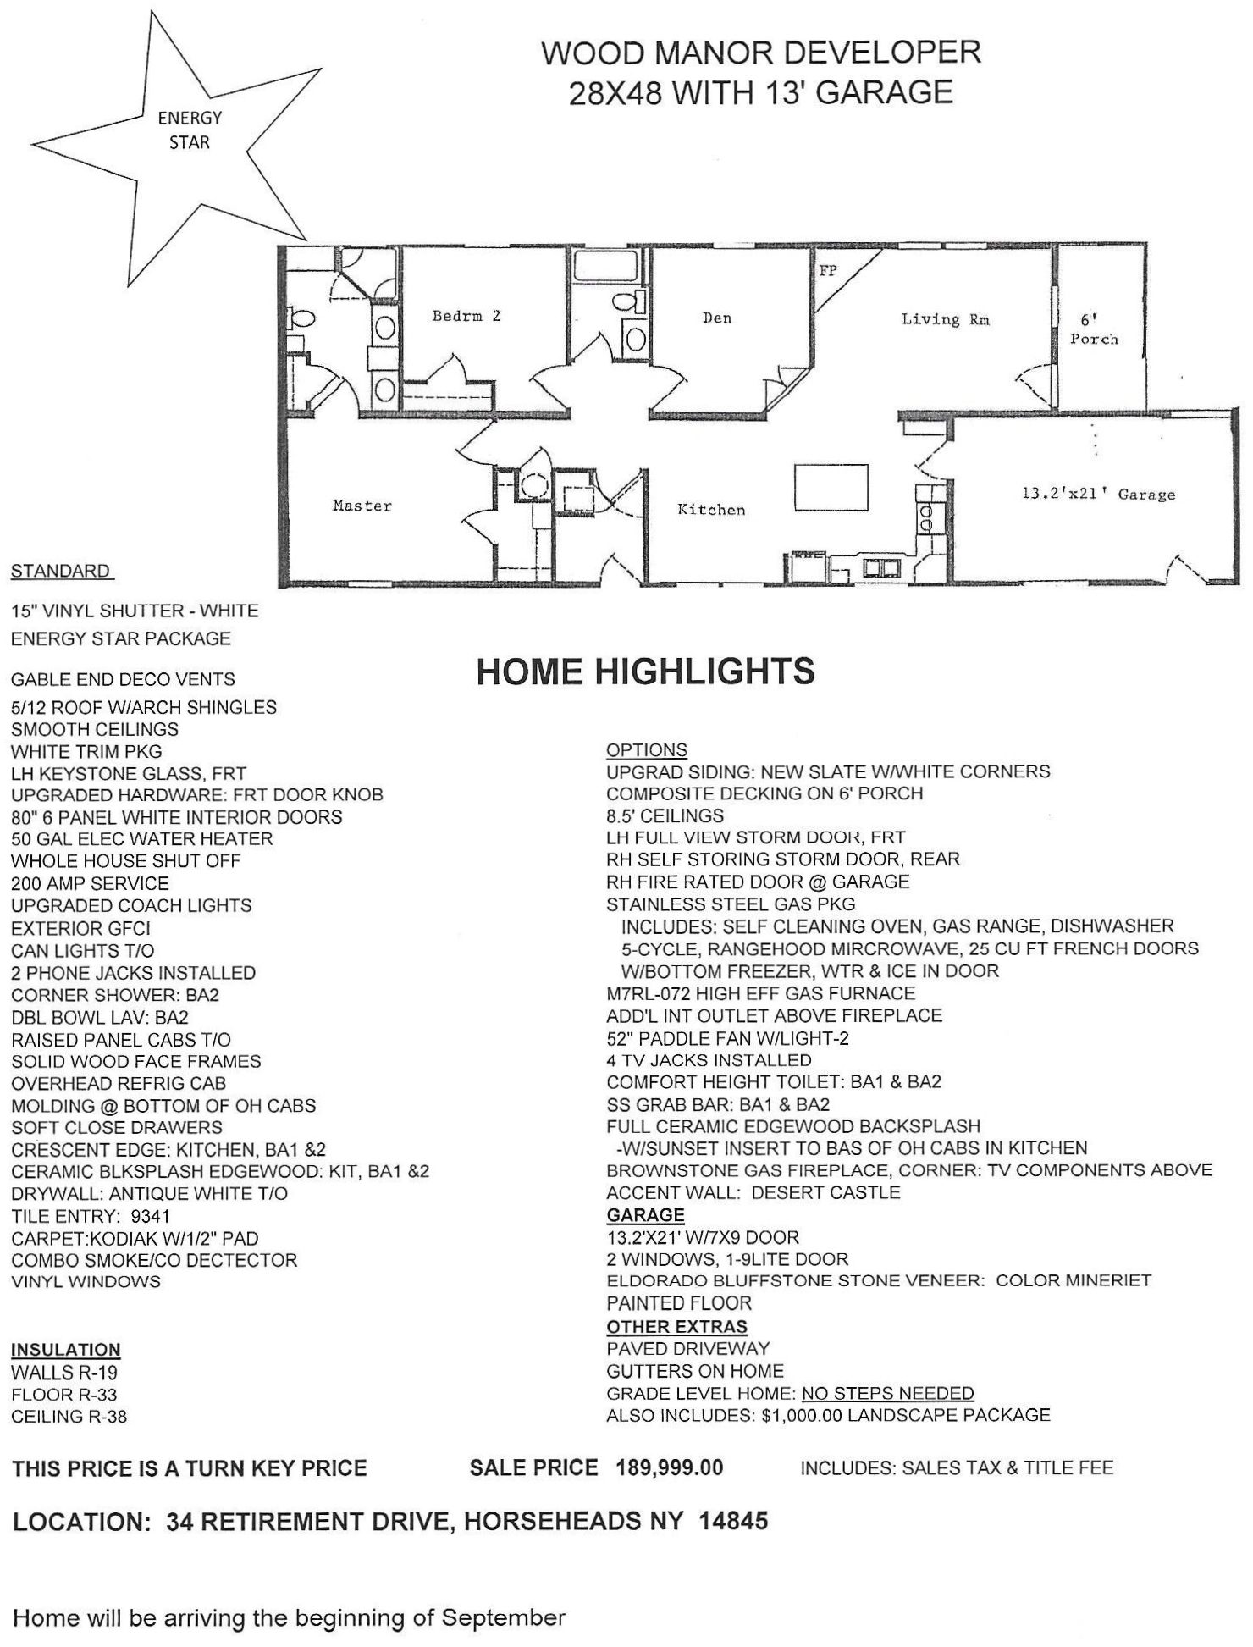

**13.2’x20’Garage**

**SKYLINE - WOOD MANOR**

1,428 square feet of living space

**LOCATION: 96 LAZY CIRCLE**

**RETIREMENT ESATES, HORSEHEADS, NY 14845**